**Sprint-II**

**Data Visualization in Cognos**

|  |  |
| --- | --- |
| **Team ID** | PNT2022TMID14605 |
| **Project Name** | A New Hint to Transportation-Analysis of the NYC Bike Share System |

**Number of Trips:**

**Customer and Subscriber with Gender:**

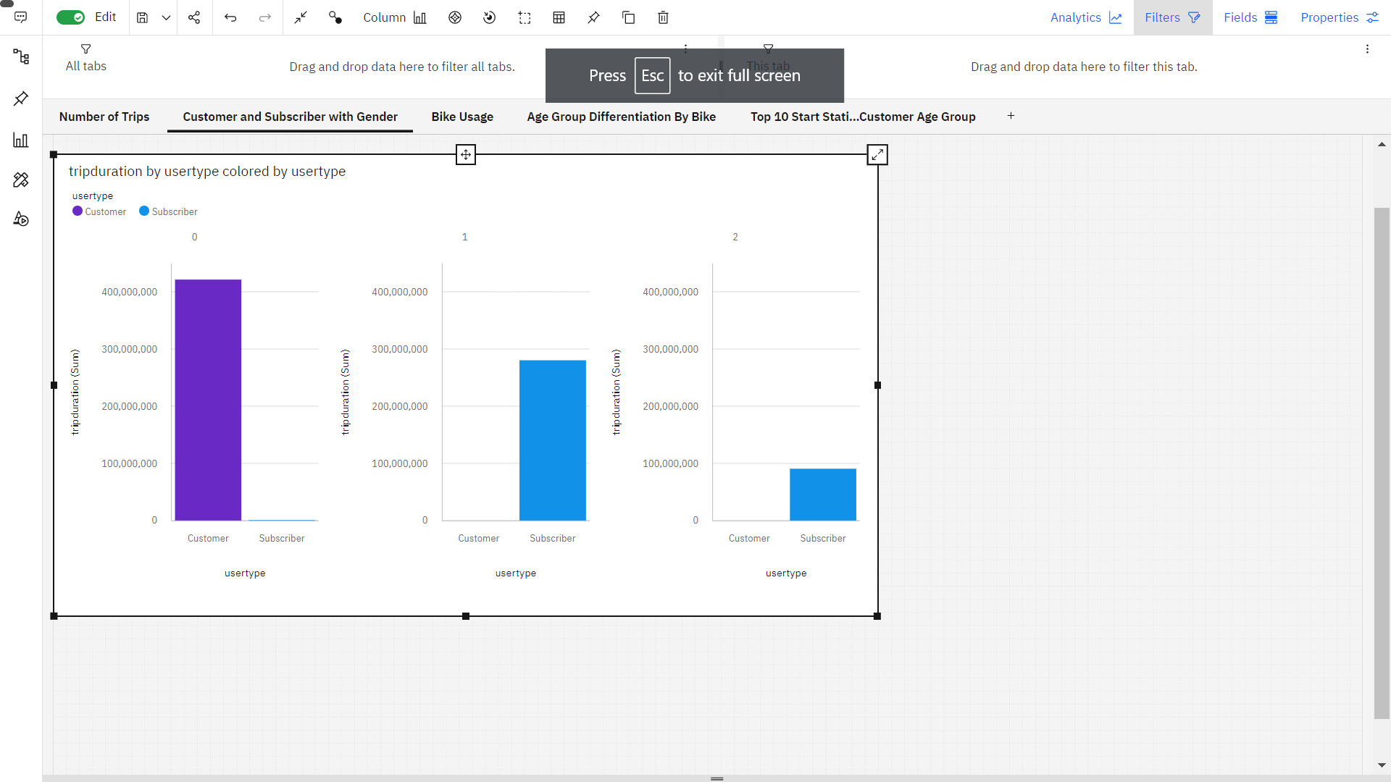

**Bike Usage:**

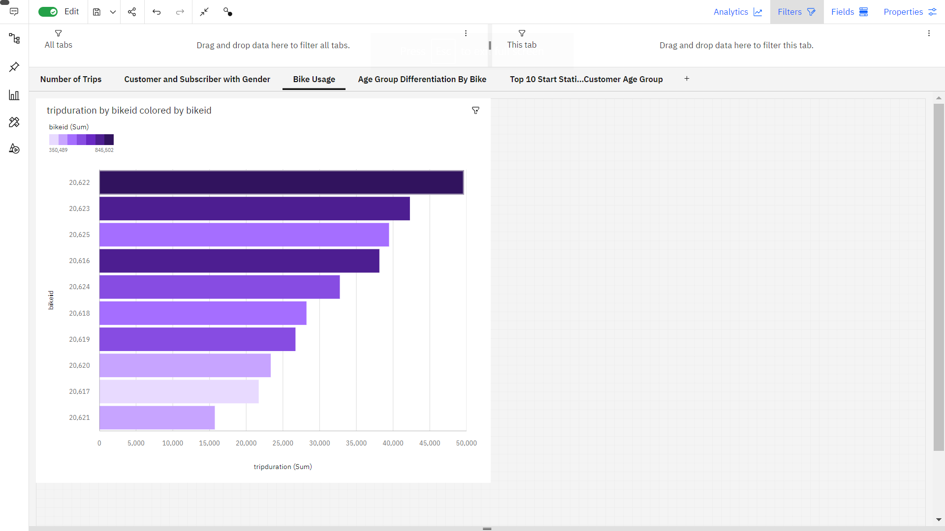

**Age group differentiation by bike:**

**Top 10 Start Station Names with Respect to Customer Age Group:**

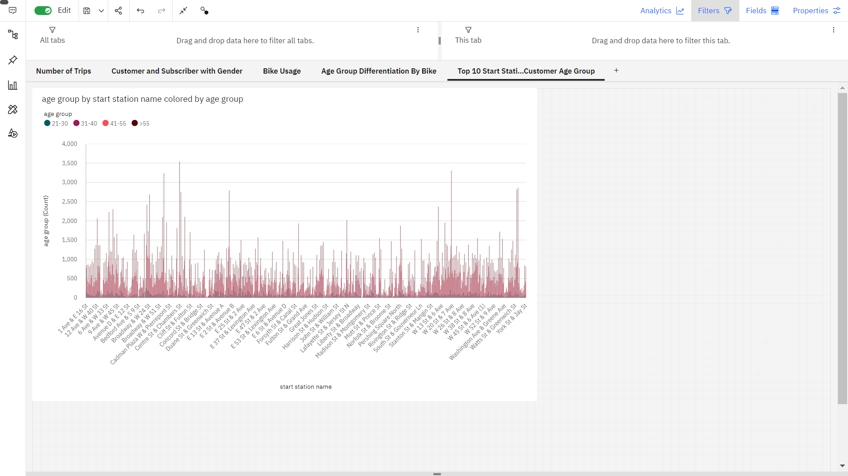

**Dashboard:**

